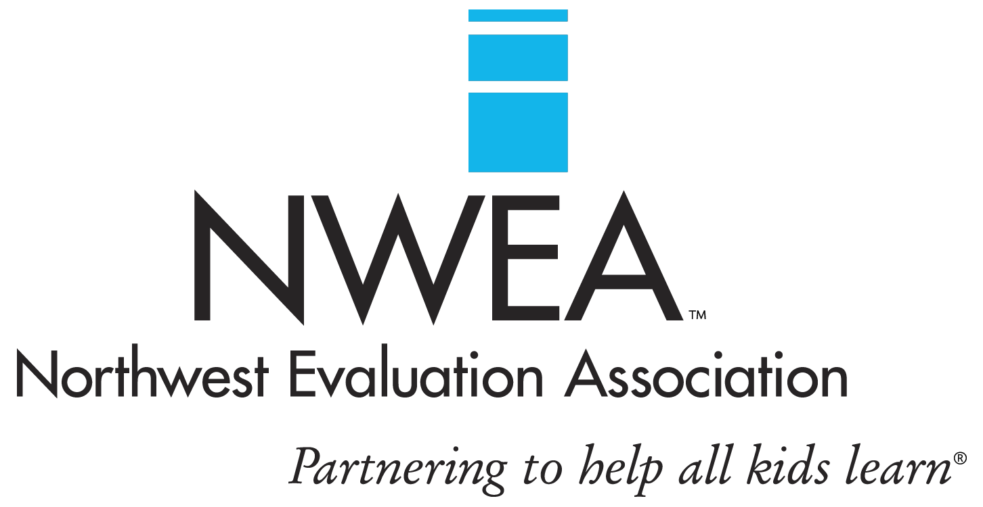

Steven Davis
Professional Development Facilitator

Cell Phone: 720-326-6713
Email: steven.davis@nwea.org

Biography:

Steve Davis attended Yale University, where he obtained a Ph.D. in English. A lifelong educator, Steve has a strong background in both training and assessment. As Senior Trainer for Encompass, LLC, Steve works extensively with USAID and other international organizations in training, program development, and evaluation. Steve started with NWEA in 2013, and
is qualified to facilitate MAP Implementation and SSD workshops. When not traveling around the country or the world, Steve makes his home in Seattle, Washington.

